CS22120 Software Development Life Cycle
Group 05 Design Specification

Author: All
Config Ref: SE.05.DS Group 5
Date: 7th December 2012
Version: 1.0
Status: Draft

Group 05
Aberystwyth University
Aberystwyth
Ceredigion
SY23 3DB
Copyright © Aberystwyth University 2012
Table of Contents
1. Introduction 3
1.1. Purpose of this Document 3
1.1.1. Scope 3
1.2. Objectives 3
2. Decomposition Description 3
2.1. Application in System 3
2.2. Significant Classes 4
2.2.1. LoginController 4
2.2.2. ViewMonsterList 4
2.2.3. ViewFriends 4
2.2.4. FriendRequest 4
2.2.5. MonsterAction 4
2.3. Requirement-Class Mapping 4
3. Dependency Description 5
3.1. Component Diagram 5
4. Interface Description 6
4.1. LoginController 6
4.2. ViewMonsterList 6
4.3. ViewFriends 7
4.4. FriendRequest 7
4.5. MonsterAction 8
5. Detailed Design 8
5.1. Sequence Diagram Description 8
5.1.1. Battle Report 8
5.1.2. Friend Request 8
5.1.3. Breeding Request 9
5.1.4. Buy/Sell Request 9
5.2. Pseudo-Code for Significant Algorithms 10
5.2.1. Breeding 10
5.2.2. Ageing 10
5.2.3. Fighting 11
6. References 11
7. Appendices 12
Appendix A - Battle Report Seq. Diagram
12
Appendix B – Friend Request Seq. Diagram 12
Appendix C - Breeding Request Seq. Diagram
13
Appendix D - Buy/Sell Request Seq. Diagram
14
8. Document Change History 14

1. Introduction

1.1. Purpose of this Document
The purpose of this document is to outline what application we are using and give a description of each significant feature.

1.1.1. Scope
This document describes the application that has been chosen, significant classes and algorithms used along with a pseudo-code.

1.2. Objectives
The purpose of this document is to show the structure of the software to allow the user to understand any significant classes or algorithms with relevant diagrams to help give a clear visual of it. The customer will be able to gather what the application will have to offer and how it has been designed to meet the requirements.
Sequence diagrams are used to visually describe what a user can do when on a specific page.

2. Decomposition Description

2.1. Application in System
The application allows users from multiple servers to connect to each other. Each user will only be able to interact with another user if they are on each other’s friends list. Users will be able to accept friend requests which will enable them to then agree to: fight, breed and buy other user's monsters. Users will be able to send friend requests and change their monster's status regarding breeding, sale and battle for other users to select and continue the result of the action.
New users will require a registration with an email, which will be used as a username and as a personal identifier used for when other users wish to add them to their friend list.
A user can have more than one monster by either trading with other users or winning ownership of a monster after winning a battle.
In order to breed, a user must label their monster available for breeding. Another user will then see that monster is available to breed with and choose whether they want to accept this. Users wanting to breed will have to pay the owner the value of the monster they want to breed with, in return of a newly bred monster.
Each monster will have characteristics (Age, Health, Strength, Defence and Aggression). These will help judge the outcome of a fight with the calculation of monster damage (shown in 5.2.3. Fighting). The monster will eventually die of old age after a certain, predetermined, amount of time. The age of the monster will be determined by comparing the system date (and time) with the particular monster’s creation date (and time). As each day passes, the monster's health will decrease. Once the monster’s health reaches 0, it will be removed from the user's monster list.
After a fight has been arranged, it will take the user to the battle report page upon which it will show the winner, any health deductions (due to injuries) from monsters which took part, if a monster died in battle and prize money given to the winner. Each battle will be a fight to the death. The monster that reaches 0 Health during the battle will be classed as the losing participant and removed from the list of monsters. After the fight, Health will be deducted from the winning monster making it possible for the winner to die after the fight. The monster will have a value which will vary depending on the attributes that monster has. Each victorious user will receive the value of the opponent's monster in virtual money, which will be sent to their cash pile.

2.2. Significant Classes

2.2.1. LoginController
This class authenticates users when logging onto (connecting) to the server. This will also authenticate user's on other servers which are trying to connect to this server.

2.2.2. ViewMonsterList
Each user will have a list of monsters. This class will allow them to view their, and their friend's monsters. The server will send requests and receive responses to view other user's monsters.

2.2.3. ViewFriends
This class will contain the relevant friend details for the user to view. This will show all the friends the user has. Friends which have been accepted will be added to the list of friends.

2.2.4. FriendRequest
In order to be friends, each request must be accepted. This class will deal with the requests and once accepted will add them to the friends list array for the user to see.

2.2.5. MonsterAction
This class allows actions to be made that the user can do with the monster – breed, battle, buy.

2.3. Requirement-Class Mapping
Requirement | Classes providing requirement
FR1 - Server-based authentication | LoginController
FR2 - Server friends list | ViewFriends
FR3 - Server monster list | ViewMonsterList
FR4 - Server monster mash management | MonsterAction, ViewFriends
FR5 - Server-server communication | MonsterAction, FriendRequest
FR6 - Client options | LoginController, ViewMonsterList, MonsterAction, FriendRequest
FR7 - Start-up of software in browser | LoginController
FR8 - Game display in browser | ViewMonsterList, ViewFriends, MonsterAction
FR9 - Friend matching | ViewFriends
FR10 - Fight notifications | ViewMonsterList
FR11 - Friends rich list | ViewFriends

3. Dependency Description

3.1. Component Diagram
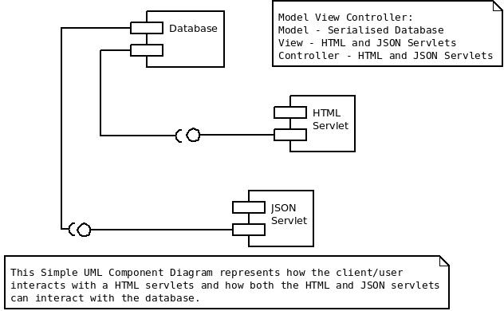

4. Interface Description

4.1. LoginController
This class extends HttpServlet so we can use it to send requests and receive responses from the relevant servers. It handles the operations relating to a user logging in.

public class LoginController extends HttpServlet{

/*
* Checks information from the database against the data entered by the user and
* redirects to another page according to the outcome of the check.
*/
protected void doGet (HttpServletRequest req, HttpServletResponse resp) throws ServletException, IOException{

}

/*
* Returns an error if data entered is not valid.
*/
protected String loginError() {

}

/*
* Logs the user in to their account.
*/
protected void login() {

}
}

4.2. ViewMonsterList

This class extends HttpServlet so we can use it to send requests and receive responses from the relevant servers.

public class ViewMonsterList extends HttpServlet {

/*
* This method retrieves the monster list for the user that has logged in and displays it
* in the view.
*/
protected void doGet(HttpServletRequest req, HttpServletResponse resp) throws ServletException, IOException{

}

}

4.3. ViewFriends

This class extends HttpServlet so we can use it to send requests and receive responses from the relevant servers.

public class ViewFriends extends HttpServlet {

/*
* This method retrieves the friend list for the user that has logged in and displays it
* in the view.
*/
protected void doGet(HttpServletRequest req, HttpServletResponse resp) throws ServletException, IOException{

}

}

4.4. FriendRequest

This class extends HttpServlet so we can use it to send requests and receive responses from the relevant servers. It deals with operations involving both sending friend requests and accepting friend requests.

public class FriendRequest {

/*
* This method sends the friend request to the relevant server.
*/
protected void requestFriend(enum action, int groupID, String userID, String friendID) throws ServletException, IOException{

}

/*
* This method sends a key to the corresponding server and stores the new friend
* in the friend list if the user decides to accept a friend request.
*/
protected void acceptFriend(enum response, String userID, String friendID, boolean result) {

}

/*
* This method returns the address of the server required for a friend request.
*/
protected String getServerAddress(HttpServletRequest req, HttpServletResponse resp) throws ServletException, IOException{

}

}

4.5. MonsterAction

This class extends HttpServlet so we can use it to send requests and receive responses from the relevant servers. This deals with sending monster related requests and responses (breed, battle, buy). This also generates battle results.

public class MonsterAction extends HttpServlet {

/*
* This method sends a monster related request to the relevant server.
*/
protected void monsterRequest(int groupID, String friendID, int friendMonsterID, String monsterName, enum action) {

}

/*
* This method responds to a monster related request, sending data to the relevant server.
* It also generates a result for a battle if the request is for a battle.
*/
protected void monsterResponse(int groupID, String ownerID, int monsterID, String friendID, int friendMonsterID, boolean response) {

}

5. Detailed Design

5.1. Sequence Diagram Description

5.1.1. Battle Report
(See Appendix A for the sequence diagram matching this description.)
This diagram is used to show the dynamic interaction between the different objects included in creating a battle report. The Home participant refers to the Home page of the website. The diagram assumes that the user has already logged in and reached the Home page. The Request Page participant refers to the Request page which is linked from the Home page. The Request page contains battle requests, friend requests, trade requests and breeding requests. For this diagram we are only interested in the battle requests. The user can return to the Home page from the Request page. The Battle Participant represents battle taking place. The battle will not be shown but will be calculated using each monster's characteristics and a random value. The Battle Report participant represents the Battle Report page. This will contain various statistics, such as prize money, injuries etc.

5.1.2. Friend Request
(See Appendix B for the sequence diagram matching this description.)
This diagram is used to show the dynamic interaction between the different objects used when executing a friend request. There are two actors and two objects involved in the friend request. The User is the actor which sends the request. The Other User is the actor which receives the request. The User's Request Page is where the User will send the request from. The Other User's Request Page is where the Other User will receive the request.

The User will go to their Request Page and create a request. The request will use the Other User's email address, which is used as a user name for the website as a unique identifier. The request will be sent to the Other User. It will appear on the Other User's Request Page. The Other User can choose to accept or decline the request. If the request is declined, the request is removed from their page. If the request is accepted, the User is added to The Other User's friends list and the Other User is added to the User's friends list.

5.1.3. Breeding Request
(See Appendix C for the sequence diagram matching this description.)
This diagram is used to show the dynamic interaction between the different objects used when executing a breeding request. There are two actors and two objects involved in the breeding request. The User represents the person placing their male monster up for breeding. The User's Friend represents a valid friend, another user of the game, who wishes to use the User's monster for breeding with one of their female monsters. The Monster List is the User's monster list which can be found on the User's Home Page. The User's Friend's Monster List can be found on the User's Friend's Home Page.

The User accesses his Monster List and chooses a monster, which must be male, and makes it available for breeding. The User's Friend will be able to see that the monster is available for breeding, and can select it from the User's Monster List. After selecting a monster, the User's Friend must select a female monster from their own list for the selected male to breed with. The number of children is calculated based on an algorithm which is included in the Significant Algorithm section. These children are then added to the User's Friend's Monster List. The User's Friend gives money to the User, which is added to the User's cash pile. Throughout this time, the male monster never actually goes over to the User's Friend; only the male monster's attributes are needed to perform the breeding algorithm.

5.1.4. Buy/Sell Request
(See Appendix D for the sequence diagram matching this description.)
This diagram is used to show the dynamic interaction between the different objects used when executing a Buy/Sell request. There are two actors and two objects involved in the Buy/Sell request. The User represents the person placing their monster up for sale. The User's Friend represents a valid friend, another user of the game, who wishes to buy a monster from the User. The Monster List is the User's monster list and can be found on the User's Home Page. The User's Friend's Monster List is found on the User's Friend's Home Page.

The User accesses their Monster List and chooses a monster to put up for sale. The User's Friend will be able to see that the monster is up for sale and can select it from the User's Monster List. After the User's Friend has selected and bought the monster, it will be added to the User's Friend's Monster List. This will only occur after the User's Friend has paid the Monster's value into the User's cash pile.

5.2. Pseudo-Code for Significant Algorithms

5.2.1. Breeding
- Receive father as parameter (who to breed the female monster with).
- Multiply the fertility rate of the mother and father monsters and then square root the result in order to generate the number of children bred.
- Initialise array of monster children of a size equal to the number of children bred as provided by the step above.
- While number of new added children < number of children bred:
  - Create a new monster.
  - Randomise whether monster is a male or female.
  - Initialise age rate by using crossover and mutation (see below for detailed explanation).
  - Initialise strength by using crossover and mutation (see below for detailed explanation).
  - Initialise evade by using crossover and mutation (see below for detailed explanation).
  - Initialise toughness by using crossover and mutation (see below for detailed explanation).
  - Initialise fertility by using crossover and mutation (see below for detailed explanation).
  - Initialise injury chance by using crossover and mutation (see below for detailed explanation).
  - Initialise date of birth with system date.
  - Initialise monster ID with an integer value.
  - Initialise owned ID with integer value of owner.
  - Add new monster to array of monster children.
- Return array of monster children.

Where:
Crossover is the genetic crossover operator which has a 50% chance of returning the first argument and a 50% chance of returning the second argument.
Mutation is a random number between 0 and 1 inclusive which is described by a binomial distribution with an arbitrary number of trials and ½ probability for each trial.

5.2.2. Ageing
Every time a monster is evaluated (e.g. every time the stable is viewed):
- Compare the monster's date of birth with the system date.
- Decrease the health of the monster based on the difference between its date of birth and the system date.
- If after the health deduction the monster's health is <= 0 the monster will be classed as dead and deleted.

5.2.3. Fighting
Once battle request has been accepted:
- Add both monsters to a new array of battle monsters.
- Make sure both monsters' details are up-to-date.
- While there are still 2 monsters in the array of battle monsters (meaning both monsters are still alive):
  - Randomly select which monster attacks this go.
  - Calculate damage to other monster using:
    - Monster aggression * monster strength * (1 – defence of other monster) * a random value.
  - Update injury to other monster with damage calculated above.
  - If the injury to the other monster is > the base health of the other monster:
    - The other monster dies and is removed/deleted from the array of battle monsters.
- Return result of battle.

6. References
N/A

7. Appendices

Appendix A - Battle Report Seq. Diagram
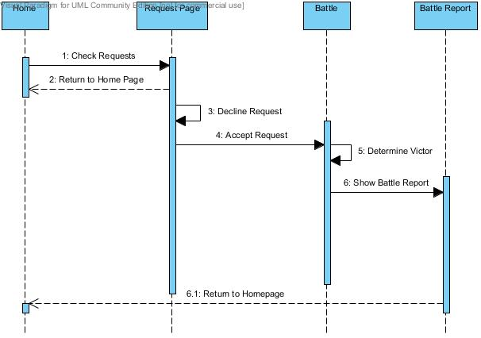

Appendix B – Friend Request Seq. Diagram
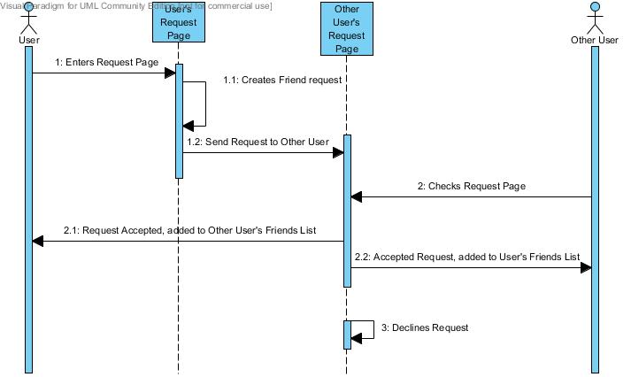

Appendix C - Breeding Request Seq. Diagram
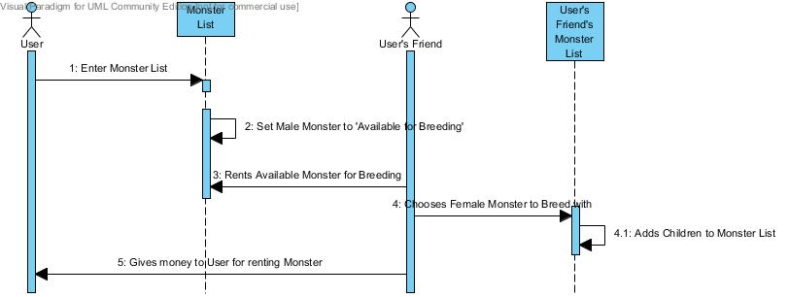

Appendix D - Buy/Sell Request Seq. Diagram
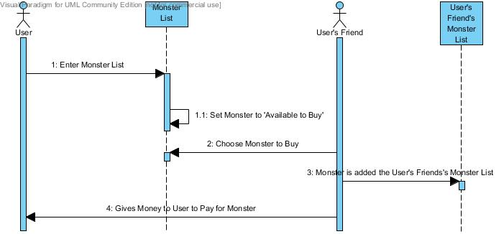

8. Document Change History
Version | CCF No. | Date | Changes made to document | Changed By
1 | N/A | 07/12/12 | This is the first draft | sjm16

